Spring Inspired ART Lessons

Study of Flowers
WELCOME SPRING!
I took my dog for a walk yesterday afternoon. On our walk, I noticed the birds chirping, the natural charm of the sunlight glistening on the trees and grass, the fluttering of a butterfly delicately be carried by a small gust of wind, and the aroma of the flowers that filled the air. Spring is so delightful!
Everything I gazed upon looked like a beautiful work of art! I feel so inspired to create. The think that amazes me is how every flower; tree, butterfly, and bird are their own special design. Each are amazing and must be represented and honored as a work of art!
Idea 1:
While on my walk, I took photos of flowers along the way. This is a great idea for anyone to do. It really makes you stop and appreciate the beauty of nature. Here are some images that I took: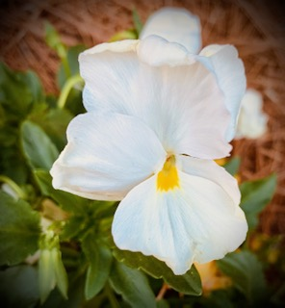 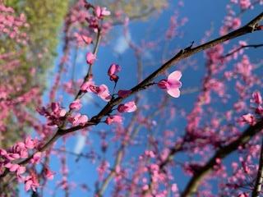 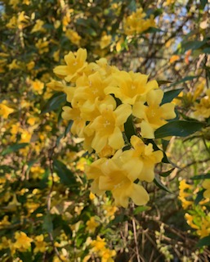 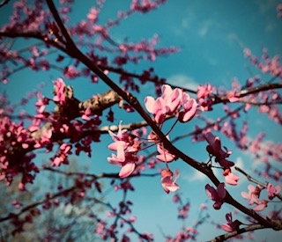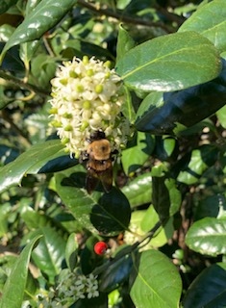 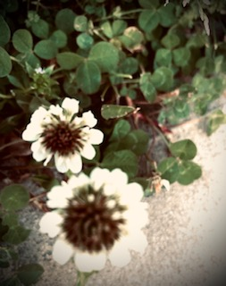 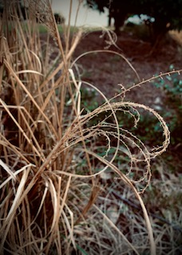 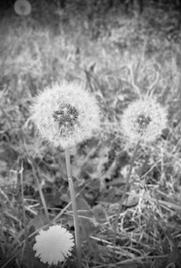
There are some really great editing features on smart phones that can be a lot of fun to play with. You can create some really beautiful images!
Some images are centered and some I have used the “rule of thirds.” This is when an image is not centered and placed withing 1/3 of the frame. Try it if you can!

