Flower Sketch Thumbnail Drawing:
A thumbnail sketch is a drawing that allows an artist to think about the image. It is how an artist will plan and think about a future work of art. It is always a good idea to create thumbnial sketches tackling a more in-depth work of art.
Below are some techniques to explore when drawing and sketching. There are future lessons that consist of creating flowers. It is a good method to practice your drawing techniques and create thumbnail sketches. The images are showing step-by-step of how to sketch, use smudge techniques, erasing highlight, and create contrast for defining detail. I will be explaining in further detail in upcoming video tutorials.
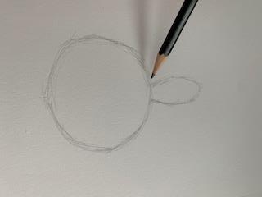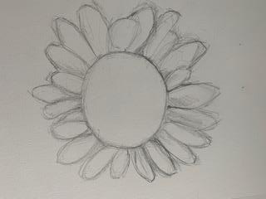
Sketch circle petals lightly. Continue drawing petals around the circle. Gesture by drawing lightly. This is a realistic flower, so pedals do not have to perfect radial symmetry.
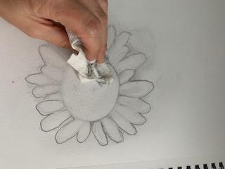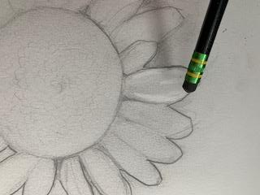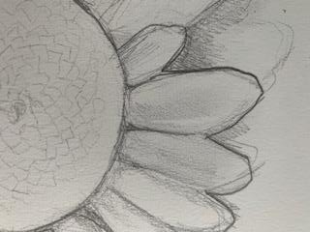
After the initial gesture of the image is complete, you can smudge the overall image, blending loose sketch marks and creating an overall neutral value (a grayed appearance). Began erasing highlights and adding darkened lines for contour definition to create a more three dimensional appearance.

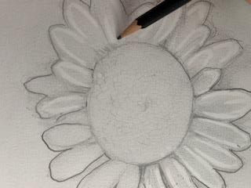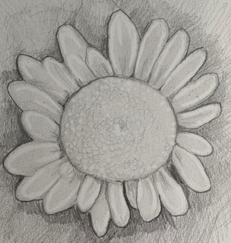
Continue to draw details and erase highlihtes for raised texture throughout the center. Shade the backgound to create contrast.

