Part 1: Draw a Diagram of a Flower
Part 2: Dissection of a Flower and Naming Parts
In many cases, artists have to learn science in order to create realistic images of things. It betters their idea of how the parts a structured. The lessons below will help you thing like a scientist in order to make your flower drawings more realistic.

Part 1: Draw a Diagram of a Flower
Use the diagram reference (use “Common Flower Parts” diagram or go to website below) to help in drawing and naming the parts of the flower.
https://sciencing.com/diagram-of-the-parts-of-a-flower-13426180.html
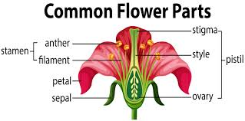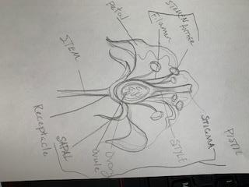
Part 2: Dissect a Flower and Name Parts
Recently, I was taking some wilted flowers out of a vase to replace them with fresh flowers. I decided to save a few to use for this lesson! This is simple. Step 1: Dissect a flower by delicately seperating the parts and scatter them onto a piece of paper. Step 2: Use the previously drawn flower diagram that you created to write the flower parts.
