Earth Day! 2020
Earth Day inspired Art Lessons
Here are some awesome activities that you can explore in honor of Earth Day that that is celebrated on April 22.
Pollinators play a very important part of our ecosystem. They assist in the pollination of plants that allows fruits and vegetables to grow. Read the website below to learn more about pollination and pollinators.
Article #1: Please read to learn more about Pollinators
https://www.fs.fed.us/wildflowers/pollinators/What_is_Pollination

Project Idea # 1
Creating Beehive with Bees
Read the article below for inspiration before beginning your project. You will not “BEE”lieve how amazing bees can be! You will also need to look at the WeDrawAnimals.com to learn how to draw a bee. Remember to practice a sketch before you begin the project. The following page will show you how to create the project step-by-step.
Article #2
https://www.npr.org/sections/krulwich/2013/05/13/183704091/what-is-it-about-bees-and-hexagons
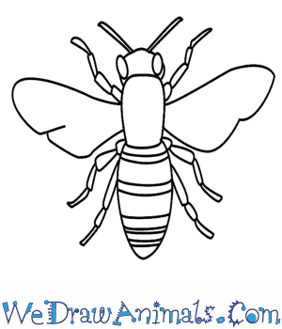
https://www.wedrawanimals.com/how-to-draw-a-bee/

Beehive with Bee Art Project Step-by-step
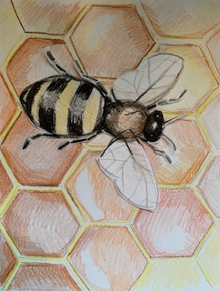

- You will need to draw beehive on a separate piece of paper. In order to draw a beehive of hexagons you will need to create one hexagon and cut it out. To create a template, you can print or trace the image above or learn how to create a hexagon from a square. This YouTube video can show you how https://www.youtube.com/watch?v=zyQJOpRKoCg.
- After creating your template, place the hexagon shape in an arrangement to look like a beehive.
I watched the YouTube video, using a post-it square. The sticky side helps keep the shape in place for tracing.

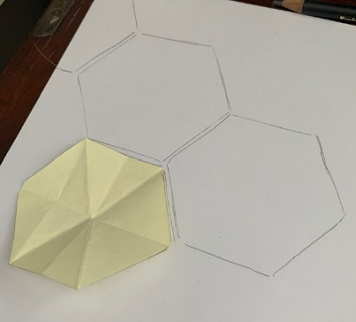 While drawing your hive, reference the image below. See the hexagons are spaced apart. Also, notice the gold and creamy yellow hues. Remember, you are only drawing the hive. You will add the bees later.

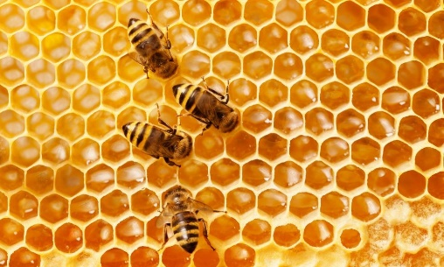 Reference Image

- Add color to complete you background hive. I uses a light creamy yellow for the frame of the boarder and different shades of gold and burnt orange for the inside part that is the honey! Reference the image above and my sample below to see how the white highlights make the honey shine!
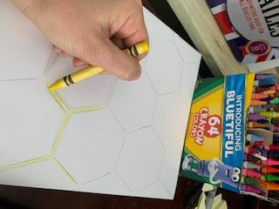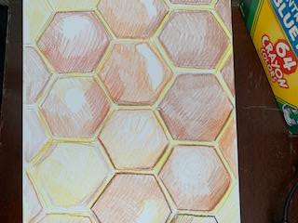
- Practice drawing multiple bees on a separate sheet of paper. Use the suggested website to draw bees https://www.wedrawanimals.com/how-to-draw-a-bee/. Use the reference image to draw your bees to the right proportion. Your bee size should be about the length of 2 hexagons. If you used the post-it square, your bee should be around 5-6 inches in length. After drawing the bee image, use the reference image for use of color. I will be using goldenrod, black, and shades of brown.

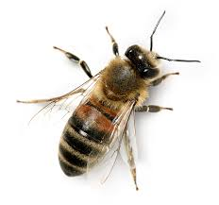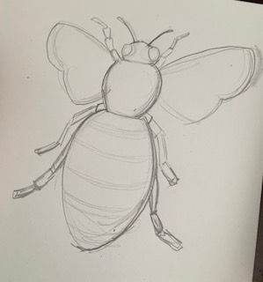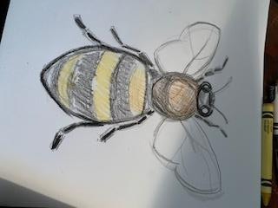
Reference Image Sample Image Sample Image withcolor Note: I colored in the sample image but plan to add mor detail once cut and pasted on hive background.
- Cut out and glue bee or multiple bees on hive background. Add more detail if need after glueing.
Completed Bee and Hive!

- If you want to email me a photo of your artwork, you can do so!
kelly.harper@ucps.k12.nc.us

